**Detection of blindness (Diabetic Retinopathy) on Retina Images of the Eye**

* P Chakri Praneeth, ** K Surya Teja, *** P D K Chaitanya Babu, **** M Yamini Srilakshmi, Department of Computer Science and Engineering, Seshadri Rao Gudlavalleru Engineering College, Gudlavalleru, Andhra Pradesh

Abstract: In this study, we will develop a system to distinguish diabetic retinopathy disease from fundus images. An effective way for identifying Diabetic retinopathy disorders such as diabetic retinopathy, hypertension, arteriosclerosis, and others is through the precise and programmed analysis of diabetic retinopathy images. In the current study, we analyzed retinal fundus photographs that were located in structured analysis of the retina storage to extract different Diabetic retinopathy features including Diabetic retinopathy, optic disc, and lesion characteristics and integrated them with CNN-based models for the identification of multiple DR diseases. In this research, deep learning was combined with convolutional neural networks (CNNs) to provide fast disease detection of DR illnesses. Several neuron and layer wise visualization approaches were used by training a neural network on a openly accessible Diabetic retinopathy disease picture dataset. This led to the discovery that when neural networks are used to diagnose diseases, they can record the colors and features of lesions corresponding to those diseases, which is similar to human made decisions. This model is used to deploy Django web framework. We investigated different Diabetic retinopathy features as inputs for convolutional neural networks to classify Diabetic retinopathy images effectively.

Keywords: Deep learning, diabetic retinopathy (DR), CNN, AlexNet, LeNet, Django, convolutional layers, classification.

**1. INTRODUCTION**

Diabetic retinopathy (DR) is the main reason of blindness in the people whose ages are between 25 to 74 years old in the developed world. After 15 years of diabetes, it affects three out of every four diabetic people. Diabetic retinopathy and associated consequences of the condition are caused by chronic hyperglycemia (high blood sugar levels). It is occurred when blood vessels in the retina at the back of the eye are damaged [1].

Over the last several decades, the number of people diagnosed with diabetes has risen rapidly, and diabetes increases the risk of a variety of eye illnesses, including diabetic retinopathy, which is one of the most serious. Even for a well–trained physician, early detection of diabetic retinopathy is a time-consuming process, which can result in delayed treatment, miscommunication, and other issues.

The significance of an automatic approach for detecting DR has been acknowledged. The categorization of retinal pictures into basic and DR images is the subject of our research. Automated strategies for diagnosing diabetic retinopathy are critical to resolving these issues. In general, binary classification using deep learning has gained good validation accuracy. The outcomes for multi-stage classification, especially for initial-stage diseases are less spectacular.

In this study, we present an autonomous DR grading system that can divide photos into two levels based on the area of eye damage. To extract specific picture properties without compromising spatial arrangement information, a convolutional neural network (CNN) convolves an input image with a predetermined weight matrix [1]. We first compare alternative architectures to find the best functioning CNN for the binary classification problem, with the goal of achieving quality standards described in the literature. We then try to train multi-class models that improve sensitivity for the mild or early-stage classes, using a variety of data preparation and augmentation techniques to improve test accuracy while also increasing the size of our effective dataset sample size [16]. Finally, for the recognition challenge, we use a deep layered CNN with transfer learning on discriminant colour space to overcome the issue of limited sample size. The AlexNet and LeNet CNN architectures were then trained and evaluated.

**2. LITERATURE SURVEY**

A research study is a piece of writing that seeks to summarise the most important aspects of current knowledge and/or methodological approaches to a specific issue. It is secondary sources, and it discusses published material in a specific subject area, as well as information in a specific subject area during a specific time period [3]. Its ultimate purpose is to keep the reader up to speed on present literature on a topic, and it serves as the foundation for other goals, such as future research that may be needed in the field. It comes before a proposed study, and it can be as simple as a list of references [4]. It usually follows a pattern and incorporates both summary and synthesis. A summary is a re-organization and reshuffling of information, but a synthesis is a re-organization and reshuffling of information. It could offer a fresh perspective on old material, or blend new and old perspectives, or it could chart the field's intellectual evolution, including significant controversies. The literature review may analyse the sources and advise the reader on the most pertinent or relevant ones, depending on the context [5].

**Review of Literature Survey**

**Title:** Retinal image preprocessing, enhancement, and registration

**Author:** Carlos Hernandez-Matasa, Antonis A. Argyrosa, Xenophon Zabulisa

**Year**: 2018

Following the introduction of the ophthalmoscope, the first fundus images were obtained. Since then, the concept of archiving and analysing retinal pictures for diagnostic purposes has existed. The initial study of retinal image processing used analogue images and focused on detecting vessels in fundus images using fluorescein. The fluorescent chemical amplifies the appearance of vessels in the image, making it easier for a medical practitioner or a computer to discover and measure them. Fluorescein angiography, on the other hand, is an invasive and time-consuming treatment that comes with a price tag for the fluorescent agent and its administration. The use of retinal image analysis in screening and diagnosis has grown as a result of advances in digital imaging and digital image processing. The capacity to evaluate fundus images accurately has encouraged the use of noninvasive fundus imaging in these fields. Furthermore, novel imaging modalities like OCT and SLO have expanded the scope and uses of retinal image processing. This study looks at both fundus imaging and SLO and OCT imaging, as well as fundus photography.

**Title:** A Deep Learning method for Automatic identification of Diabetic Eye Disease

**Author:** Yanchun Zhang, Rubina Sarki, Khandakar Ahmed and Hua Wang

**Year**: 2020

Diabetes Mellitus, generally known as diabetes, is a disorder in which a person's body either does not respond to or produces insufficient insulin from their pancreas. Diabetics are more likely to develop a range of eye problems over time. Because of developments in machine learning techniques, early identification of diabetic eye disease via an automated system provides considerable benefits over manual detection. A lot of higher research on the detection of diabetic eye disease have recently been published. This paper examines automated methods for diagnosing diabetic eye disease from several angles. The purpose of this study is to give crucial insight into research communities, healthcare professionals, and diabetes patients by offering a full overview of DR eye disease detection methods, including cutting-edge field methods.

**Title:** Deep Learning-based retinal image analysis

**Author:** Baidaa Al-Bander

**Year:** 2018

Ophthalmic image interpretation is mainly done by qualified clinical professionals. However, because of the number and complexity of these images, as well as the wide range of disease and expert opinion, there has been a growing interest in computer-assisted assessment and diagnosis of these images. A cost-effective strategy with high sensitivity and specificity, independent of human involvement, and robust enough to be deployed to large populations in a timely manner to identify retinal illnesses has piqued researchers' curiosity. To address critical issues in various retinal image analysis tasks, this thesis introduces unique deep learning approaches based on CNNs. This study looked at three types of retinal image processing tasks: fovea and optic disc localization, choroid and optic disc/cup segmentation, and disease and lesion categorization. The simultaneous recognition of the centres of the fovea and the optic disc from colour fundus images is considered a regression problem in the first retinal image analysis task.

**Title:** Preprocessing, augmentation, and registration of retinal images

**Author**: Xenophon Zabulisa, Carlos Hernandez-Matasa, Antonis A. Argyrosa,b

**Year:** 2018

Diabetes retinopathy is a medical image processing application. The retinal pictures are analyzed to determine whether or not the patient has DR. Manually grading the photos to determine the degree of DR is, however, time consuming and resource intensive. Only when the small blood vessels within the retina are destroyed can this condition be detected. Blood will flow from this tiny blood vessel, and the fluid on the retina will create characteristics. The types of features engaged here due to fluid and blood leaks from blood vessels are thought to be the most essential elements to investigate. Pre-processing, segmentation, and classification are the three phases of diabetes retinopathy detection procedures. The NN technique is employed in this study to classify the diabetes component of the image. The proposed model has been implemented in MATLAB, and the results are examined using specific parameters.

**2.1 Method Used in Existing System**

They want to be able to categorise every fundus image accurately. To create our neural networks, we use a deep CNN architecture with an extractor and a smaller decoder for a particular mission. However, the small quantity of data, it is hard to train the encoder from scratch. As a result, the encoder's initialization is ImageNet-pretrained CNNs. We describe a multi-task learning strategy for diagnosing diabetic retinopathy. There are 3 decoders in use. The CNN backbone is used to train the classification, regression, and ordinal regression heads to solve their tasks using features collected from the CNN backbone. The classification head generates a one-hot encoded vector in this case, with each stage's existence represented by 1. The regression head produces a real number between 0 - 4.5, which is then rounded to an integer that represents the illness stage. For the ordinal regression head, we use the method described in (Cheng, 2007). As a result, this head's purpose is to foresee everything up to and including the target. The final forecast is obtained by fitting a linear regression model to the outputs of three heads. We train all heads and the feature extractor at the same time to save time during training. We keep the linear regression model frozen until the post-training stage [1][4].

**3. PROPOSED WORK**

The proposed approach consists of stage pretreatments to remove diabetic retinopathy images from data sets and standardize them to size, followed by classification using a CNN which is a deep learning technique. It proposed a system for diagnosing diabetic retinopathy. It describes how to do an experimental investigation of Images of various Diabetic Retinopathy are collected as samples. The shape and texture-oriented elements of the image are relied upon as the image's primary qualities. The classification of diverse Diabetic retinopathy disorders has been greatly aided by effective disease detection and deep learning with CNN [8]. Using a CNN trained with a publicly available Diabetic retinopathy illness image-dataset, a number of neuron- and layer-wise visualisation approaches were applied. The Diabetic retinopathy disease detection utilising a color-based classification model is shown in the sample screenshots. Also, for the Django framework, to deploy this model web application.

**3.1 SYSTEM ARCHITECTURE**

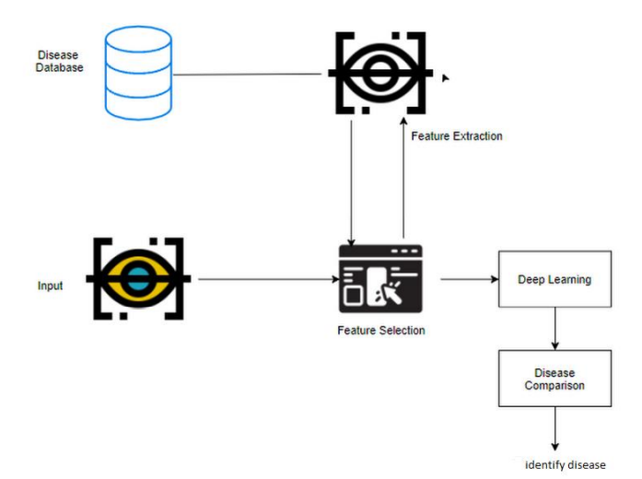

**4. FEASIBILITY STUDY**

**Splitting the data:** Training data and test data are the two types of data that are commonly used. The model learns from the training set, which has a known output, in order to generalise to new data in the future. It uses Python's TensorFlow library and the Keras technique to test our models using a test dataset (or subset).

**Construction of a Detecting Model:** Deep learning needs data gathering that have huge amount of past images. This model was trained and tested to ensure that it was accurate in its predictions.

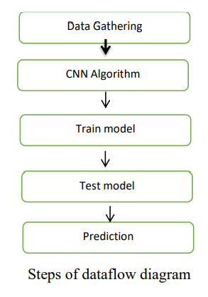

**5. METHODOLOGY**

**Preprocessing and training the model:** The dataset is preprocessed like Image reshaping, resizing and converting it into an array format. The test image is also subjected to similar processing. A dataset including about pictures of retinal illness images, each of which can be utilized as a software test image.

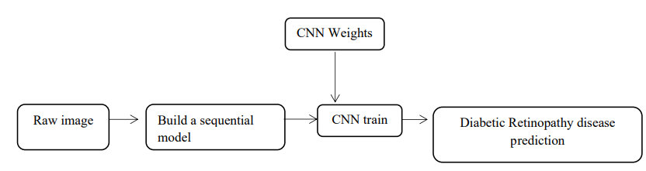

The CNN model is trained using the train dataset to recognise the test image and illness. Dense, Dropout, Activation, Flatten, Convolution2D, and MaxPooling2D are some of the layers in CNN. If the retinal image in the dataset contains the disease, the program can recognize it after the model has been effectively trained. Following successful training and preprocessing, the test image and trained model are compared in order to forecast the disease.

**CNN Model steps:**

**Conv2d:**

2D convolution is a simple process at its core: you start with a kernel, which is just a simple matrix consists of weights. This kernel traverses the 2D input data, doing elementwise multiplication on the segment of the input it is currently working on, and combines the results into one output pixel. The kernel continues the procedure for each point it glides over, changing a 2D matrix of characteristics into another 2D matrix of characteristics. The outgoing features are basically the weighted sums of the input features (with the weights being the kernel's own values) positioned approximately in the same place as the output pixel on the input layer [17].

**Flatten layer:**

It's used to flatten the image's dimensions once it's been convolved. Dense: This is the hidden layer that is used to build this a fully linked model. Dropout is employed to avoid overfitting on the dataset, and dense means that the output layer only has one neuron that determines which category each image belongs to. The input is flattened using the flatten command [15].

**Dense layer**

In any neural network, a dense layer is a layer that is deeply connected with its preceding layer which means the neurons of the layer are connected to every neuron of its preceding layer. This layer is the most commonly used layer in artificial neural network networks [15].

**Dropout layer**

The Dropout layer, which aids in the reduction of overfitting, assigns input units to 0 at irregular intervals at each phase of the training process. Inputs which are not assign as 0 are scaled up by 1/ (1 - rate) to maintain the entire amount. Dropout layer is only active if the training parameter is set to True, which means that no data is dropped during inference. When fit model is used, training is automatically set to True, and in remaining cases, when calling the layer, you can manually set the kwarg to True [15].

**Image Data Generator:**

It rescales the image, applies shear in a certain range, zooms the image, and flips the image horizontally. This Image Data Generator contains every possible image orientation [18].

**Training Process:**

The function train_datagen.flow_from_directory is used to prepare data from the train dataset directory. The image's goal size is specified by Target_size. To prepare test data for the model, call Test_datagen.flow_from_directory, and follow the same steps as above. Fit_generator is used to fit the data into the model created above, and steps_per_epochs are used to determine how many times the model will execute for the training data.

**Epochs:** It indicates how many times the model will be trained in both forward and backward passes.

**Validation process:** The validation/test data is loaded into the model by using validation data. The number of validation/test samples is indicated by validation steps.

**ARCHITECTURE OF CNN**

**CONVOLUTIONAL NEURAL NETWORK:**

Artificial neural networks such as CNN are one sort of artificial neural network. CNNs are neural networks with one or more convolutional layers that analyse images, classify data, and segment it.

**TYPES OF CNN:**

• AlexNet

• LeNet

**5.1 ALEXNET:** AlexNet is a CNN that has a big impact on machine learning, especially when it comes to applying deep learning to vision systems. It was the first network to increase speed by using a GPU. AlexNet's contains five convolutional layers. Each layer employs convolutional filters and the ReLU nonlinear activation function [6].

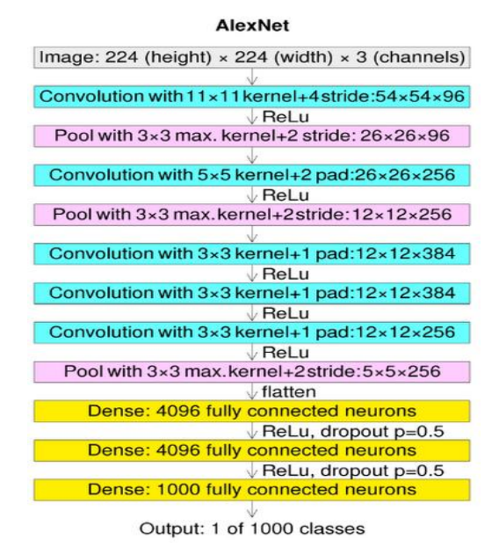

**(Architecture of AlexNet)**

**5.2 LENET:** One of the first convolutional neural networks was LeNet, and it was responsible for the emergence of deep learning. The eventual result was termed LeNet after several years of investigation and many interesting iterations [7].

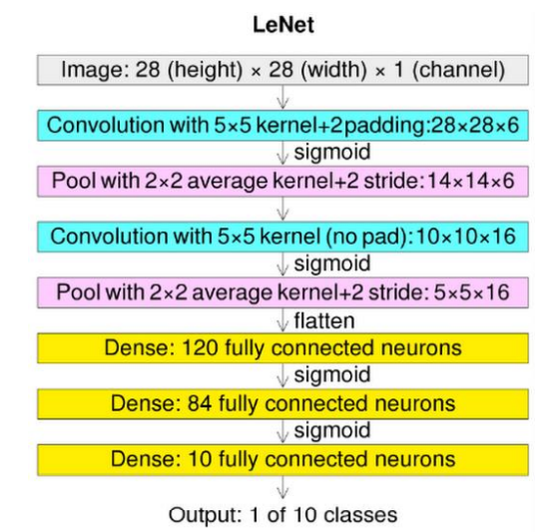

**6. IMPLEMENTATION**

**6.1 Dataset**

The image data for this study came from Kaggle, which included 270 fundus photos of the left and right eye. All of the photos are divided into two categories: diabetic retinopathy and no diabetic retinopathy. This model was trained using 200 images, and the remaining images were utilised to test it. We considered same distribution of diverse datasets to be a basic aspect of this type of data. We didn't make any changes to the dataset distribution (under sampling, oversampling, etc.). Among all of the datasets, 640x480 is the smallest native size [2].

**6.2 List of Modules**

1. Manual Net 2. AlexNet

3. LeNet 4. Deploy

**6.2.1 Modules Description**

**6.2.1.1.** **IMPORT THE GIVEN IMAGE FROM DATASET:**

We must use the keras preprocessing picture data generator function to integrate our data set, as well as produce size, rescale, range, zoom range, and horizontal flip. Then, using the data generator tool, we import our image dataset from the folder. We set train, test, and validation here, as well as target size, batch size, and class-mode. From here, we must train using our own built network by layering CNN.

**No Diabetic Retinopathy**

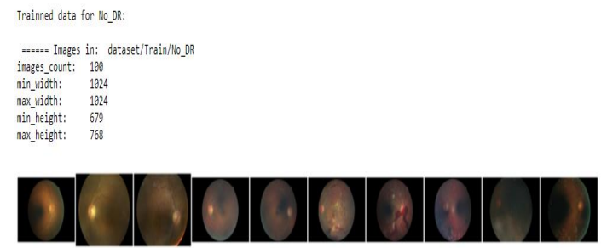

**Having Diabetic Retinopathy**

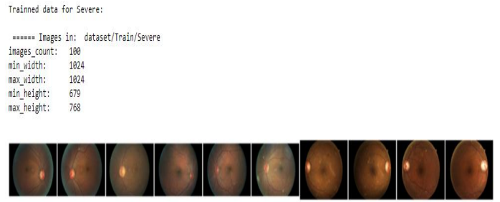

**6.2.1.2. TO TRAIN THE MODULE BY GIVEN IMAGE DATASET:**

Using functions like classifier and fit generator we are going to train our dataset with the help of training process per each epoch, for the total amount of epochs, for validating data and finally for steps for validation steps.

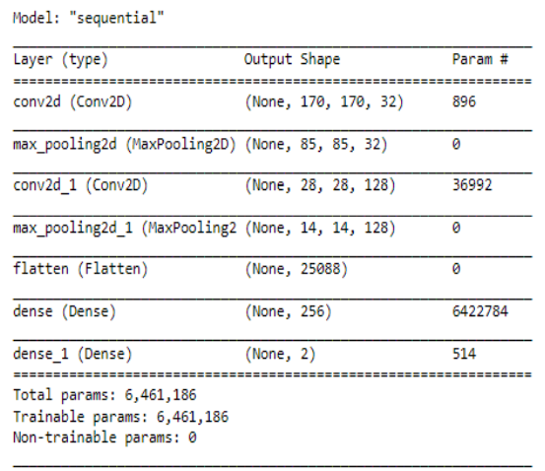

**6.2.1.3. WORKING PROCESS OF LAYERS IN CNN MODEL:**

**Input Layer:** The image data is saved in the input layer of CNN. Three-dimensional matrices are used to represent image data. It will have to be reshaped into a one column. Before being fed into the input, an image must be transformed to 784 x 1 [15].

**Convo Layer:** It is also called as the Feature Extractor Layer because it extracts features present in the given image. To start, a piece of the input data is attached to the Convo layer, which conducts the originally stated convolution as well as generating the dot product between the receptive field and the filter. As a result of the method, the final volume is treated as a single integer. Then apply a Stride filter to the next receptive field with same input image and continue the procedure. This approach will be done until the entire image has been processed. The output of this layer will be the input for the next layer [15].

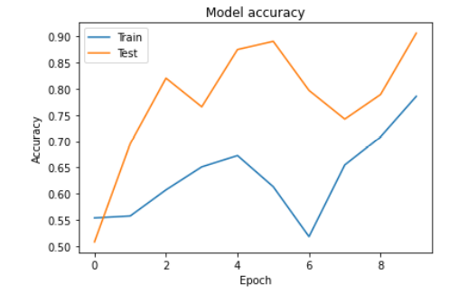

**Pooling Layer:** After convo layer, a pooling layer is introduced to reduce the spatial volume of the input image. It is introduced between the two fully connected layers. As a result, the only strategy for reducing the spatial volume of the input image is to use maximum pooling. The 4*4 input shrinks to 2*2 dimensions [15].

**Fully Connected Layer (FC):** The completely linked layer includes biases, neurons and weights. It links neurons from one layer to another layer. It's used to teach how to organise the images into different groups [15].

**SoftMax Layer:** It is the last layer in CNN which is also called as Logistic layer. It is located just under the fully connected layer. For binary classification, Logistic is utilized, and for multiclassification, SoftMax is employed [15].

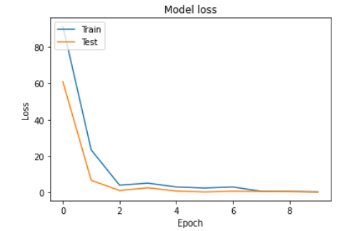

**Output Layer:** The label, which is one-hot encoded, is stored in the output layer. Now you know everything there is to know about CNN [15].

**6.2.2 DEPLOY**

In this, the learned model is transformed into a hierarchical format file (.h5) and then integrated in our Django framework to provide a superior experience and forecast if the given OCT picture is Diabetic Retinopathy or Not Diabetic Retinopathy [9].

**6.2.2.1 django**

Django is a high-level web framework that allows you to easily create secure and stable websites. Django is a web framework created by experienced developers that handles a tremendous job so you can concentrate on designing your project rather than reinventing the wheel. It's open source and free, with a thriving community, standard requirements, and a range of free and paid support options [9][10][11].

**7. CONCLUSION**

It focuses on how a CNN model was used to identify the structure of DR disorders utilising fundus image data from a specific dataset (trained dataset) and previous data set. The following are some of the implications of this for DR disease prediction. The important thing of the CNN classification framework is, ability to classify images automatically. Eye illnesses are the leading cause of blindness, and they are frequently incurable because patients are detected too late. We included an overview of strategies for detecting anomalies in diabetic retinopathy images in this work, which included retinopathy image data collecting, preprocessing procedures, feature extraction methods, and classification kinds.

**8. REFERENCES**

[1] Borys Tymchenko1 a, Philip Marchenko2 b and Dmitry Spodarets3 c 1 Institute of Computer Systems, Odessa National Polytechnic University, Shevchenko av. 1, Odessa, Ukraine 2Department of Optimal Control and Economical Cybernetics, Faculty of Mathematics, Physics and Information Tecnology, Odessa I.I. Mechnikov National University, Dvoryanskaya str. 2, Odessa, Ukraine 3VITech Lab, Rishelevska St, 33, Odessa, Ukraine tymchenko.b.i@opu.ua, p.marchenko@stud.onu.edu.ua, [dmitry.spodarets@vitechlab.com](mailto:dmitry.spodarets@vitechlab.com) Deep Learning Approach to Diabetic Retinopathy Detection arXiv:2003.02261v1 [cs.LG] 3 Mar 2020

[2] <https://www.kaggle.com/c/diabetic-retinopathy-detection/data>

# [3] [Wejdan L.AlyoubiWafaa M.ShalashMaysoon F.Abulkhair](https://www.sciencedirect.com/science/article/pii/S2352914820302069#!) Diabetic retinopathy detection through deep learning techniques: A review

[4] <https://www.nature.com/articles/s41467-021-23458-5>

[5] <https://towardsdatascience.com/blindness-detection-diabetic-retinopathy-using-deep-learning-on-eye-retina-images-baf20fcf409e>

[6] <https://medium.com/mlearning-ai/alexnet-and-image-classification-8cd8511548b4>

[7] <https://pyimagesearch.com/2016/08/01/lenet-convolutional-neural-network-in-python>

[8] <https://towardsdatascience.com/wtf-is-image-classification-8e78a8235acb>

[9] <https://developer.mozilla.org/en-US/docs/Learn/Server-side/Django/Deployment>

[10] <https://www.w3schools.com/html/>

[11] <https://www.w3schools.com/css/default.asp>

[12] <https://docs.anaconda.com/anaconda/navigator/index.html>

[13] <https://www.jetbrains.com/pycharm/>

[14] <https://www.youtube.com/watch?v=ejkRh9obVjk>

[15] https://towardsdatascience.com/understand-the-architecture-of-cnn-90a25e244c7#:~:text=The%20different%20layers%20of%20a,and%20the%20fully%2Dconnected%20layer.

[16] Elia J. Duh,1 Jennifer K. Sun,2 Alan W. Stitt3, Diabetic retinopathy: current understanding, mechanisms, and treatment strategies, [10.1172/jci.insight.93751](https://dx.doi.org/10.1172%2Fjci.insight.93751)

[17] https://keras.io/api/layers/convolution_layers/convolution2d/

[18]https://www.tensorflow.org/api_docs/python/tf/keras/preprocessing/image/ImageDataGe nerator